Romanian NMA Training Placement Scheme
Third semestrial scientific report, March 2026

Claudiu Adam (EUMETSAT Placement Scheme Trainee, NMA)

ABSTRACT
This report documents the third semester of the COALITION-4 adaptation project at the Romanian National Meteorological Administration. The work focuses on two nowcasting targets: lightning hazard probability and rain rate classification. A complete data preprocessing pipeline was built from scratch to ingest Romanian S-band radar mosaic products, LINET lightning observations, MSG SEVIRI and MTG FCI satellite data, and NWCSAF cloud products. Based on the Grad-CAM and Xi correlation feature analysis conducted in the previous reporting period, DEM and NWP inputs were excluded from the training configuration. The study area, defined on a 1536×768 pixel grid in EPSG:31700 Stereo70 projection, is partitioned into a fixed 6×3 grid of 256×256 pixel patches, with DBSCAN clustering applied to rain rate fields to identify active convective patches for each timestep. Two independent COALITION-4 branches were trained on 17 days of data from May 2025: a lightning branch using weighted focal loss and a radar branch using categorical crossentropy with five precipitation classes. Parallel MSG and MTG pipelines were evaluated. Results show that both models converge, with lightning predictions overestimating spatial extent and radar predictions remain dominated by the lowest intensity class. Future work targets dataset expansion to six months and attention-based architectural modifications.

1. Introduction
The COALITION-4 deep learning nowcasting system, originally developed by MeteoSwiss [1], is being adapted to Romanian meteorological conditions. The second semestrial report established knowledge distillation [6] from the Swiss teacher model, DBSCAN-based convective cell identification, and a Grad-CAM and Xi [4][5] correlation feature analysis confirming DEM as detrimental and NWP products as marginally contributive (ξ ≈ 0.52) relative to other products utilized, especially when compared to radar and satellite products.
The current pipeline was thought out to train two independent COALITION-4 branches (lightning hazard and rain rate classification) rather than a single distilled radar branch. The preprocessing chain was rebuilt to integrate both MSG SEVIRI and MTG FCI satellite streams in parallel. The feature set was reduced to radar, lightning, satellite, and NWCSAF products. Two training datasets were generated (one per satellite stream), both combined with identical radar, LINET, and NWCSAF products. The training period covers 17 days from 15th to 31st of May 2025.

2. Data sources and preprocessing
The primary inputs are Romanian national radar mosaic products reprojected from native coordinates to EPSG:31700 Stereo70 at 1 km resolution via KD-tree nearest-neighbour mapping. The main radar products are RZC (rain rate, mm/h), CZC (composite reflectivity, dBZ), EZC-20 (echo top at 20 dBZ, km), LZC (vertically integrated liquid, kg/m²), and CPCH (hourly precipitation accumulation, mm), all at 10-minute cadence. Three LINET-derived lightning products are computed at 15-minute resolution: stroke density, peak current, and binary occurrence. The occurrence product serves as the binary label for the lightning branch. Standard binary crossentropy is unsuitable for this task because the extreme class imbalance causes the model to converge on predicting "no lightning" everywhere, achieving high accuracy while learning nothing about convective structure. This happens because the gradient signal is dominated by the overwhelming majority of negative pixels: each training step pushes the model toward lower loss on clear-sky predictions, while the sparse positive pixels contribute negligibly to the total gradient. The model finds a loss minimum by outputting near-zero probability everywhere, ignoring the lightning signal. Focal loss modifies standard crossentropy by adding a modulating factor (γ) to reduce the loss contribution from well-classified pixels.
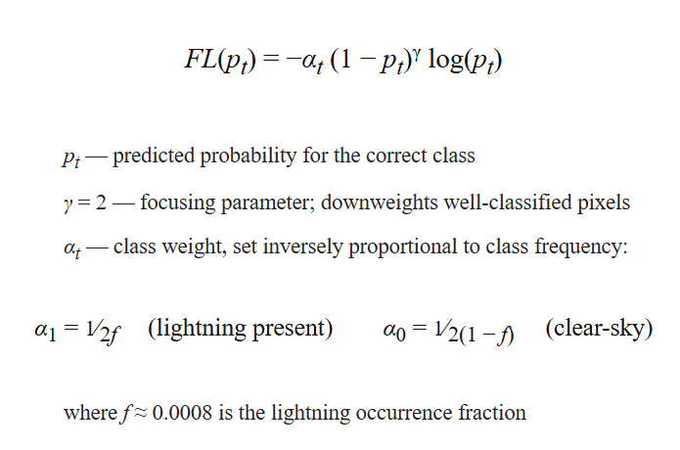
, where
p_{t} — predicted probability for the correct class
γ = 2 — focusing parameter; downweights well-classified pixels
α_{t} — class weight, set inversely proportional to class frequency
α₁ = 1/(2f) — weight for lightning-present pixels
α₀ = 1/(2(1−f)) — weight for clear-sky pixels
f ≈ 0.00012 — pre-computed lightning occurrence fraction across the study period.

Four NWCSAF cloud products (ctth_alti, ctth_tempe, cmic_phase, cmic_cot) are regridded from geostationary coordinates to the Stereo70 target grid.
Two satellite streams are processed in parallel. MSG SEVIRI rapid-scan provides five channels at 3 km resolution and 15-minute cadence: VIS006 (0.6 µm), IR_039 (3.9 µm), IR_108 (10.8 µm), WV_062 (6.2 µm), and WV_073 (7.3 µm). MTG FCI provides five spectrally equivalent channels (vis_06, ir_38, ir_105, wv_63, wv_73) at 1 km or 2 km resolution and 10-minute native cadence. FCI data is downloaded in a selective manner, considering that Romania intersects only chunks 35, 36, and 37 out of 40 total in the full-disk scanning pattern, yielding a significant reduction in download volume (Figure 1), with chunks 34 and 38 taken as a safety buffer zone.
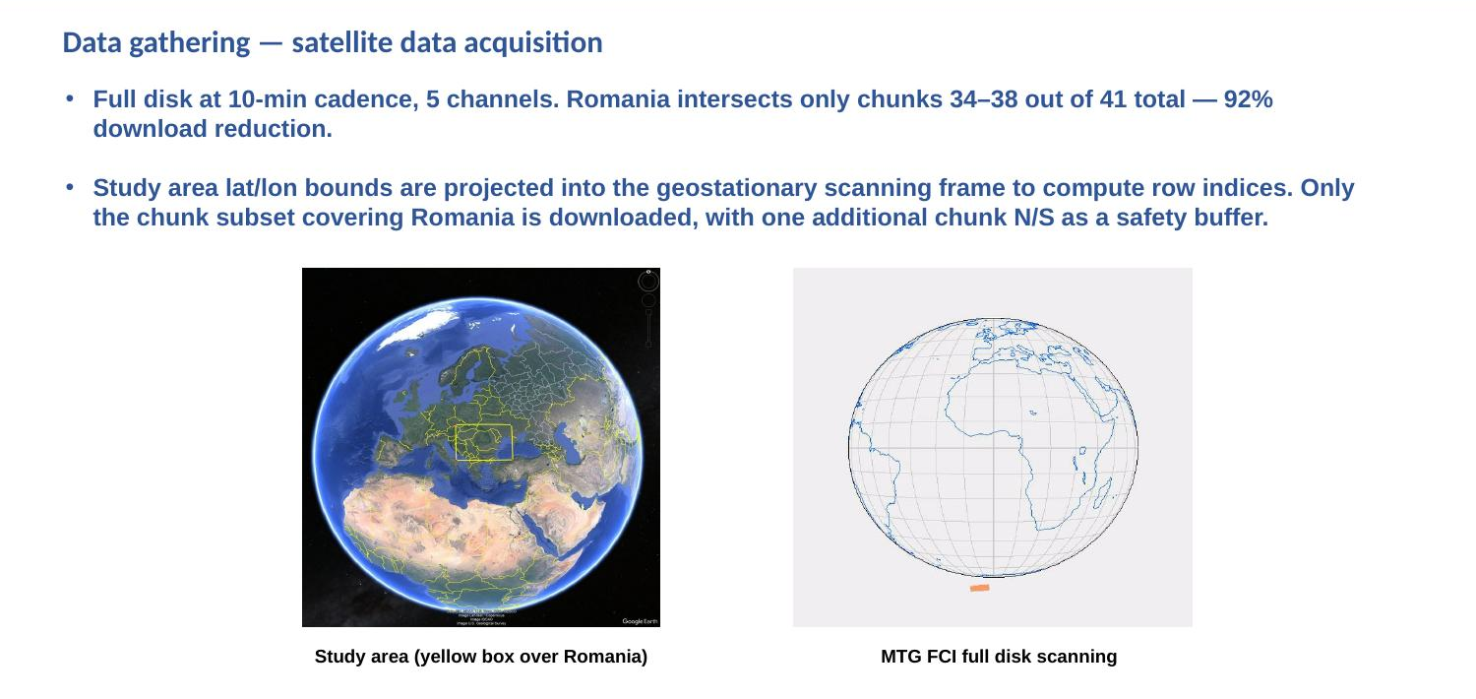
Figure 1. MTG FCI full-disk scanning pattern. Only chunks 34–38 are downloaded from MTG data to cover the study area over Romania.
The COALITION-4 architecture operates on a uniform 15-minute grid. Radar and MTG FCI data (10-minute cadence) require interpolation for the intermediate :15 and :45 timestamps. Products at :00 and :30 are used directly. Lucas-Kanade optical flow is applied to satellite channels, while Farnebäck polynomial expansion is used for radar fields. However, both methods introduce artefacts: Lucas-Kanade produces pulsating structures and Farnebäck over-smooths features. Both methods need to be avoided as they introduce additional errors into the system and should be replaced with a more standard approach of selecting the nearest neighbor observations.

3. Patch extraction and dataset creation
The Romania study area is defined on a 1536×768 pixel grid in EPSG:31700 Stereo70 projection, yielding approximately 1 km pixel spacing. This grid is divided into a fixed 6×3 arrangement of 18 non-overlapping patches, each 256×256 pixels. Patches are numbered 1 to 18 left-to-right, top-to-bottom (row 1: patches 1–6, row 2: 7–12, row 3: 13–18).
For each timestep, the DBSCAN clustering algorithm [2] is applied to the reprojected RZC rain rate field to identify the active regions. Pixels with rain rate exceeding 10 mm/h are clustered using an epsilon neighbourhood radius of 5 pixels and a minimum cluster size of 20 pixels. A binary mask is generated from all identified clusters, and any patch from the 6×3 grid containing at least one non-zero pixel in this mask is marked as active (Figure 2).

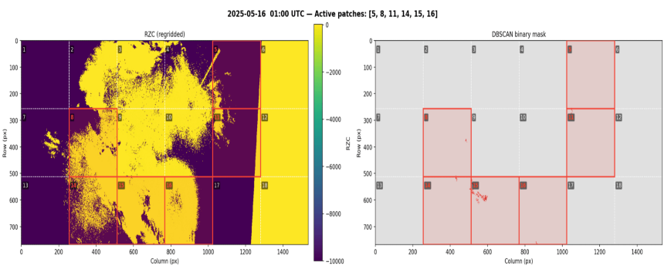
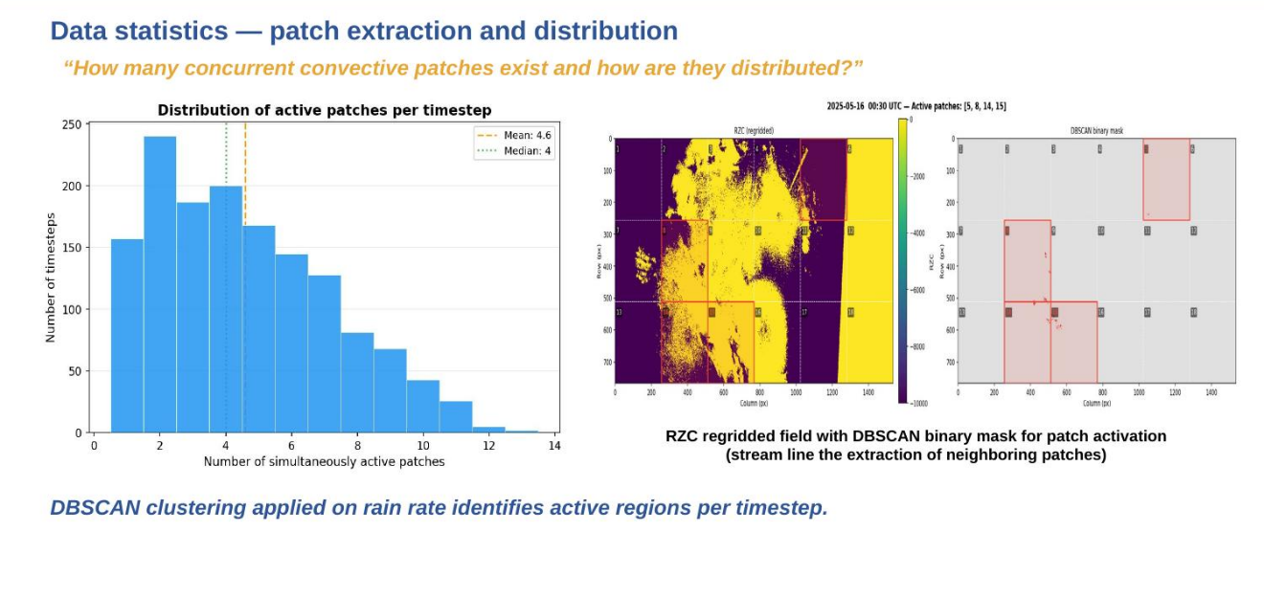

Figure 2. Distribution of simultaneously active patches per timestep (left), with mean 4.6 and median 4. RZC reprojected field with DBSCAN binary mask overlaid on the 6×3 patch grid (right). Red-outlined patches are active.
The study period of 15–31 May 2025 yields 1450 active timesteps across 17 dates at 15-minute resolution. The spatial heatmap of patch activation frequency (Figure 3) reveals a strong geographic bias: central patches (3, 9, 15) are most active (45–51.7% of timesteps), while eastern boundary patches (5, 11, 17) show substantially lower activation (1.7–14.9%). Patches 6, 12, and 18 (rightmost column) are never active, likely because they fall outside effective radar coverage. The diurnal cycle shows onset around 10 UTC, peak between 12–18 UTC, and decay into evening hours.

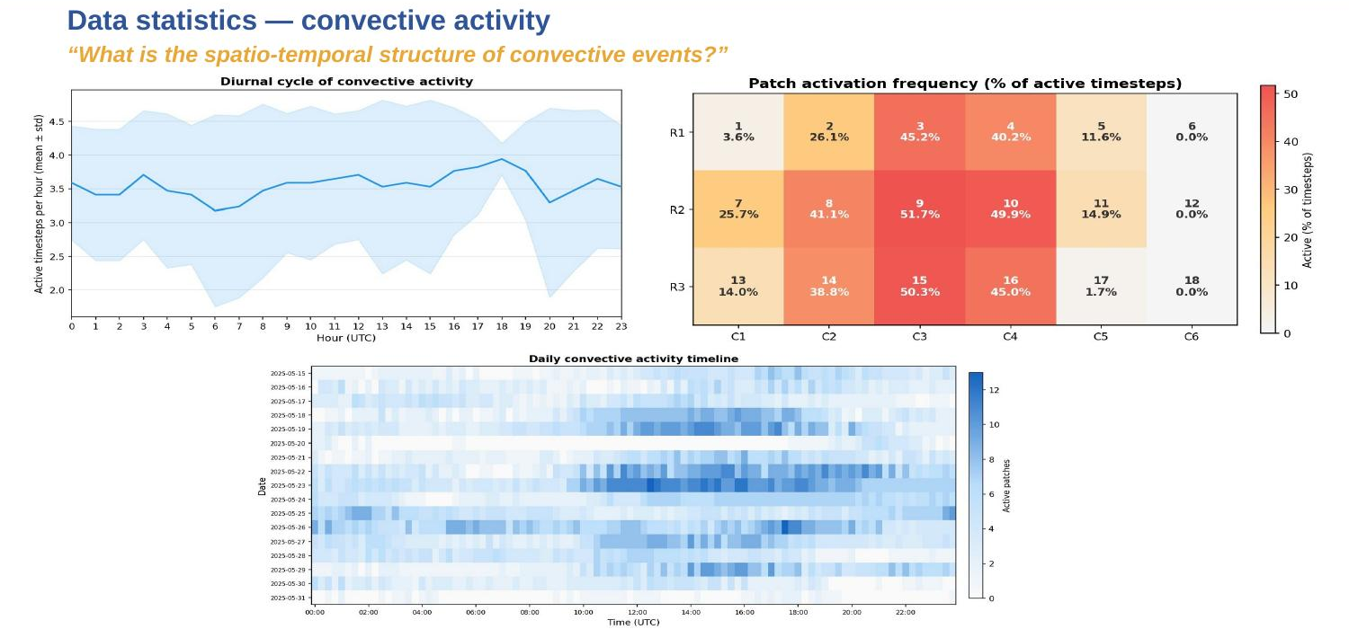
Figure 3. Diurnal cycle of convective activity (top-left), patch activation frequency as percentage of active timesteps (top-right), and daily convective activity timeline across the 17-day study period (bottom).
Lightning activity (Figure 4) peaks on 23 May with over 80 active timesteps out of 96 for all three LINET products. The occurrence product shows highest counts, followed by current and density. Low-activity days include 16 May, 20 May, and 31 May.
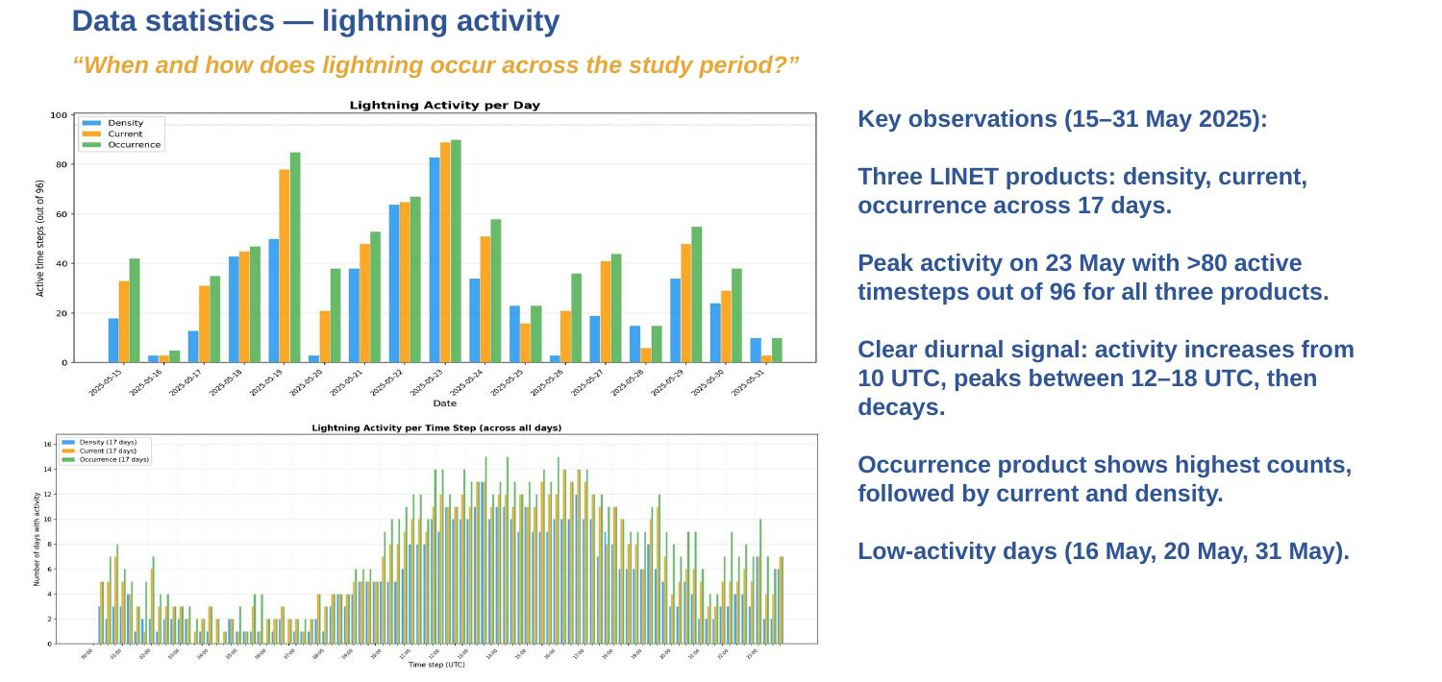
Figure 4. Lightning activity per day (top) and aggregated per 15-minute timestep across all 17 days (bottom) for density, current, and occurrence products.
Within each day, samples are split into contiguous temporal blocks following the approach of Czibula et al. [3]: the first 10% of each 6-hour period is assigned to testing, the next 10% to validation, and the remaining 80% to training. This preserves temporal ordering within each block and prevents data leakage from correlated consecutive timesteps, while ensuring all three splits sample from the same diurnal distribution.
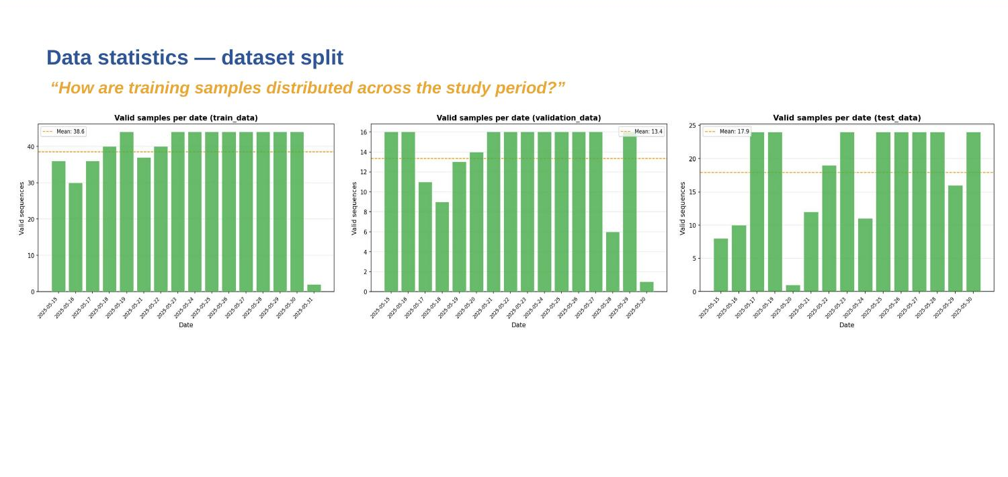
Figure 5. Number of training samples per date for each dataset split (training, validation, test).

4. Labels and loss functions
Raw RZC rain rate values (mm/h) are discretized into five classes through fixed thresholds: R < 10, 10 ≤ R < 20, 20 ≤ R < 30, 30 ≤ R < 40, and R ≥ 40 mm/h. Each pixel is encoded as a one-hot vector of dimension five. The loss function is categorical crossentropy.
Lightning labels are binary: 1 where lightning is present in the LINET occurrence product and 0 elsewhere. The loss function is weighted focal loss with γ = 2, where the focusing parameter downweights confident clear-sky predictions and concentrates gradient updates on storm-boundary pixels.

5. Results
Four model configurations were trained for 10 epochs each on the 17-day May 2025 dataset. Four datasets were generated, split across two prediction targets (rain rate classification and lightning hazard) and two satellite input configurations (MSG SEVIRI and MTG FCI). All four share the same radar, LINET lightning, and NWCSAF products derived from MSG observations; the only variable is which satellite imagery is included in the input stack. The COALITION-4 recurrent CNN architecture is used for all configurations, with independent branches for lightning (+15, +30, +45-minute probability maps) and radar (+15, +30, +45-minute rain rate class maps). Mixed-precision training (float16) is enabled. Training curves for MSG and MTG are shown in Figures 6 and 7.

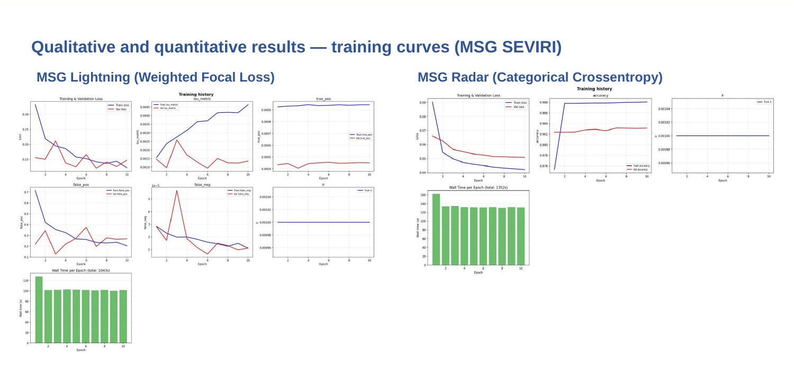
Figure 6. MSG SEVIRI training curves. Left: lightning branch (weighted focal loss, IoU, true/false positives/negatives). Right: radar branch (categorical crossentropy, accuracy, learning rate).
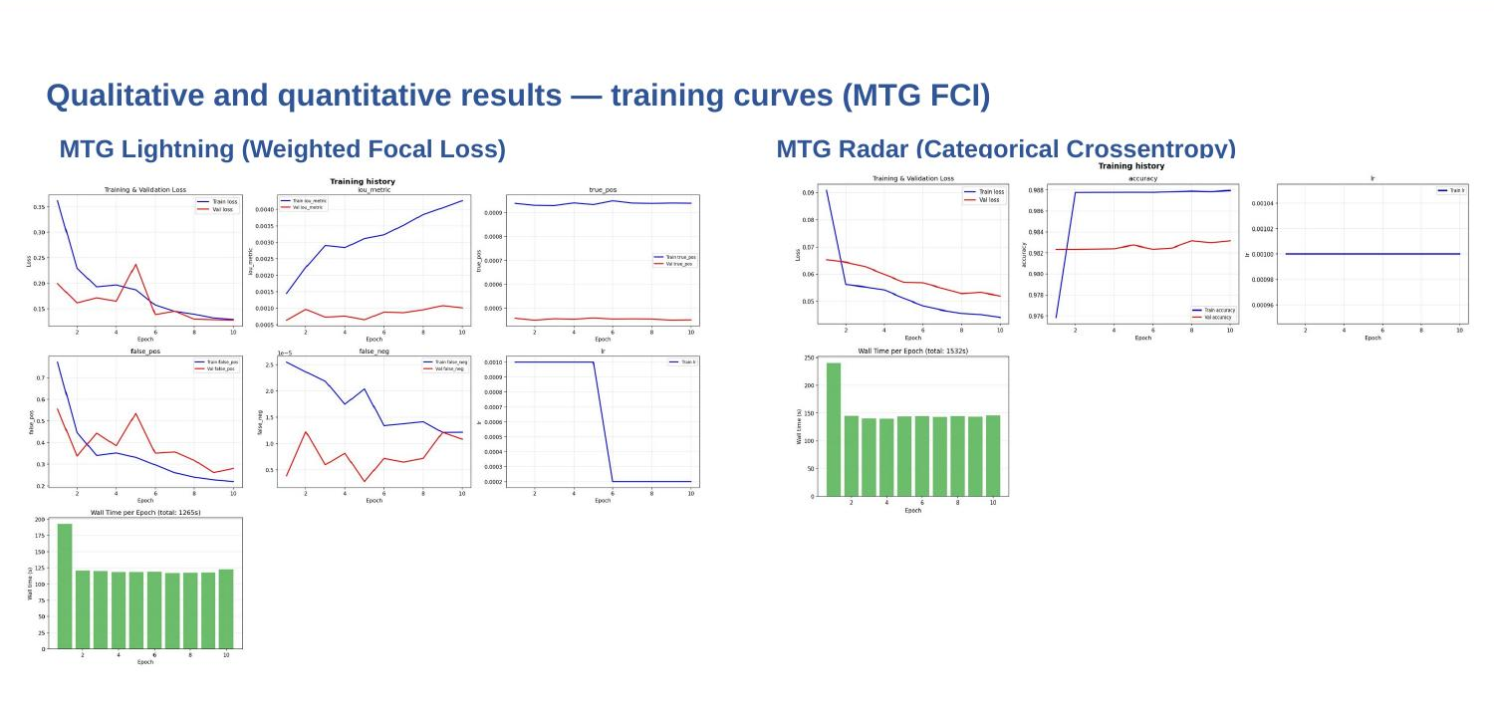
Figure 7. MTG FCI training curves. Same layout as Figure 6. Comparable convergence behaviour to MSG.
For both MSG and MTG, the lightning branch shows training loss decreasing from approximately 0.32 to 0.14 over 10 epochs, with more variable validation loss. The IoU metric increases and true positive counts rise, confirming that the model learns to detect lightning regions. However, at a 0.5 probability threshold, predicted lightning fields cover areas substantially larger than actual lightning occurrence (tens of thousands of pixels versus hundreds), resulting in high false-positive rates. MTG predictions show slightly more spatially coherent probability fields than MSG, attributable to higher native spatial resolution (1–2 km vs 3 km).
The radar branch converges smoothly for both satellite streams: training loss decreases from approximately 0.09 to 0.04, and pixel-level accuracy rises from 0.976 to 0.988. Wall time per epoch is approximately 135 seconds (MSG) and 150 seconds (MTG). However, the high accuracy is misleading because the R < 10 mm/h class dominates the pixel distribution: the model achieves high accuracy by predicting almost all pixels in the lowest class. Higher-intensity categories (20–40 mm/h) are barely represented in predictions. This limitation is consistent across both MSG and MTG and is not resolved by higher input resolution. MTG convergence is comparable to MSG. The third row in the radar prediction panels shows per-pixel confidence, defined as the maximum softmax probability across the five output classes. High confidence (yellow) indicates the model assigns most probability mass to a single class, while low confidence (blue or green) indicates probability is spread across multiple classes. The spatial structure in the confidence map reveals where the model detects convective activity but cannot commit to a higher precipitation class — for instance, a pixel may assign 0.4 to R<10, 0.25 to 10≤R<20, 0.18 to 20≤R<30, 0.12 to 30≤R<40, and 0.05 to R≥40, resulting in low confidence (0.4) despite the argmax still selecting R<10. This makes the confidence map more informative, for visualization purposes only, when compared to the categorical prediction at this stage of training, as it exposes the model's partial learning of precipitation structure that the argmax alone hides. MTG advantages include higher spatial resolution and enhanced multi-spectral information, while drawbacks include shorter archive, larger file sizes requiring chunk-filtering, and optical flow interpolation artefacts at the resampling step. Qualitative predictions for both MSG and MTG are shown in Figures 8 and 9.
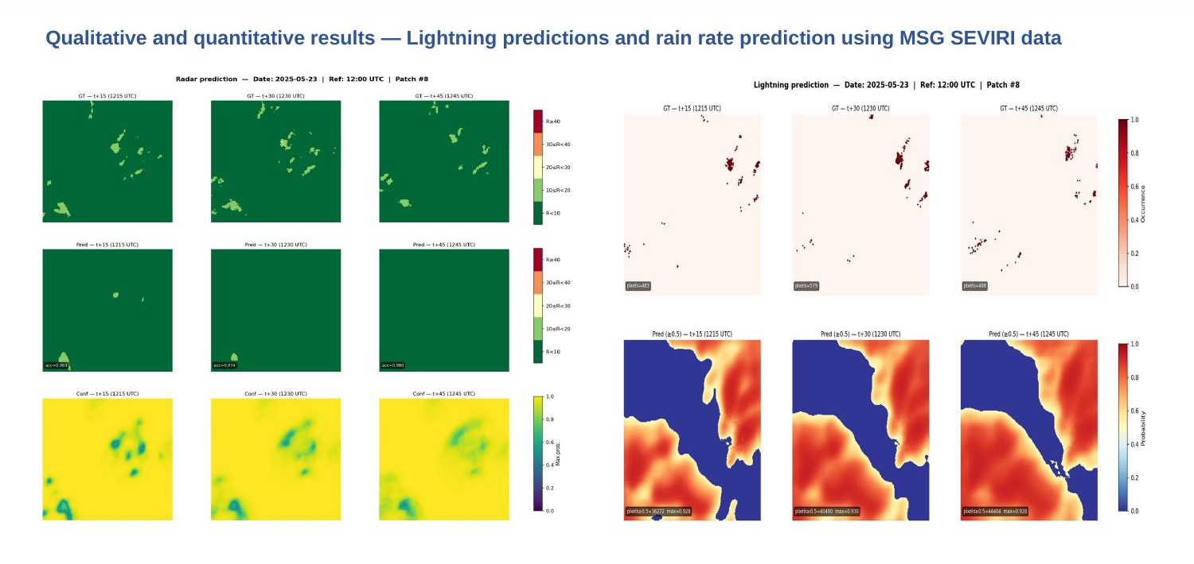
Figure 8. MSG SEVIRI qualitative predictions for 23 May 2025, patch 8, reference 12:00 UTC. Left: radar (ground truth, prediction, confidence maps at t+15/+30/+45). Right: lightning (ground truth occurrence vs predicted probability at ≥0.5 threshold).
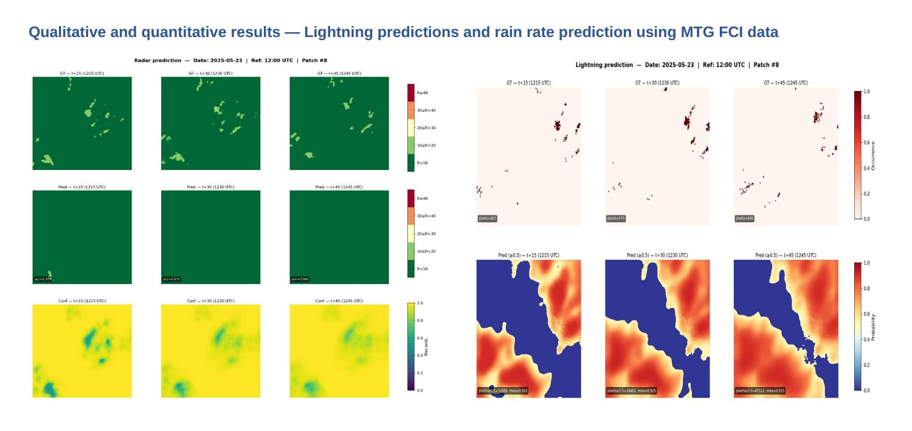
Figure 9. MTG FCI qualitative predictions for the same case. Structurally similar to MSG; radar dominated by R<10 class, lightning probability overestimates spatial extent.

6. Future work
The primary near-term objective is increasing the training dataset from 17 days to six months (the original COALITION-4 used six months). Lightning hazard maps require sharpening, as the current model produces probability fields covering areas much larger than observed lightning. Post-processing techniques and architectural modifications will be investigated.
For rain rate nowcasting, attention-based mechanisms derived from Transformer self-attention will be explored to capture long-range spatial dependencies that the current CNN misses. Optical flow-based guidance will be applied as post-processing to improve displacement accuracy at longer lead times. The knowledge distillation pipeline will be refined for operational integration, and deployment within ANM’s framework is planned for real-time evaluation during the 2026 convective season.

7. Extra activities
A bursary proposal was submitted to the EUMETNET E-AI Programme titled “Does Generative AI Map the Hail Trajectory Using Geostationary Satellite, Radar, and Auxiliary Data?”. The framework addresses class imbalance for severe hail events through two modules: Module A (TRecViT U-Net) for radar reflectivity prediction from FCI imagery using gated Linear Recurrent Units with a conditioned diffusion decoder, and Module B (Masked Diffusion Transformer) for generating multi-channel FCI observations conditioned on radar reflectivity, with masking at a 30 dBZ threshold. Data sources include MTG FCI (10 channels at 1 km), EUMETNET OPERA CIRRUS composites, and ESWD hail reports.

References
[1] Leinonen, J., Hamann, U., Sideris, I. V., & Germann, U. (2022). Thunderstorm nowcasting with deep learning: a multi-hazard data fusion model. Geophysical Research Letters. https://doi.org/10.1029/2022GL101626
[2] Ester, M., Kriegel, H.-P., Sander, J., & Xu, X. (1996). A Density-Based Algorithm for Discovering Clusters in Large Spatial Databases with Noise. KDD-96 Proceedings.
[3] Czibula, G., et al. (2024). SepConv-ens: an ensemble approach for radar nowcasting as classification on Romanian data. KES 2024.
[4] Selvaraju, R. R., et al. (2019). Grad-CAM: Visual Explanations from Deep Networks via Gradient-based Localization. International Journal of Computer Vision. https://doi.org/10.1007/s11263-019-01228-7
[5] Chatterjee, S. (2020). A new coefficient of correlation. Journal of the American Statistical Association. http://arxiv.org/abs/1909.10140
[6] Hinton, G., Vinyals, O., & Dean, J. (2015). Distilling the Knowledge in a Neural Network. NIPS Workshop. http://arxiv.org/abs/1503.02531

